iOS Developer Assignment

Build a News App
Time: 3 days | Platform: SwiftUI or React Native

The App: "Layman" — Business, Tech & Startups Made Simple
Layman is a simplified news reader that covers business, tech, and startups. The core idea: take complex news and present it in plain, everyday language — in layman's terms.
Your job is to build a fully functional version of this app that matches the provided mockup exactly. The attached mockup PDF is your design spec — the look, feel, color palette, typography, and layout should be replicated as closely as possible.
Design Reference: See the attached Clean and Modern App Portfolio Mockup Presentation.pdf for all screens and visual specifications. Key mockup pages are also embedded in this document below.

Screens

1. Welcome Screen
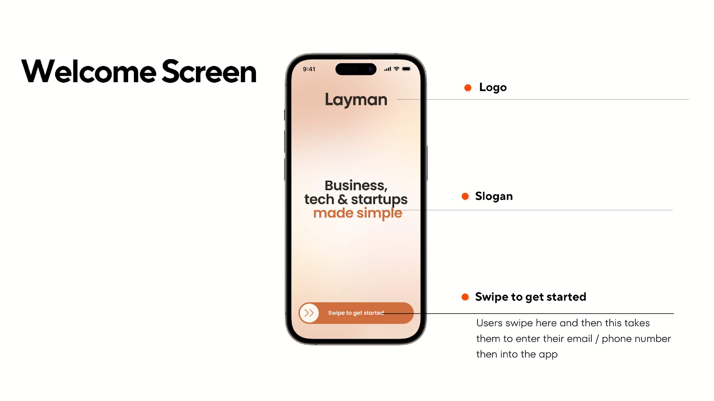
- Logo: "Layman" logo
- Slogan: "Business, tech & startups made simple" — the words "made simple" should be in the accent orange color
- Background: Warm peach-to-orange gradient (see mockup above)
- "Swipe to get started": A swipeable action at the bottom that takes the user to the authentication screen

2. Auth Screen
- Email/password sign-up and login via Supabase
- Clean, minimal UI that matches the app's warm color palette
- Handle basic validation and error states
- Secure session management (persist login state across app launches)

3. Articles Screen (Home)
This is the main screen users see after logging in — every time they open the app.
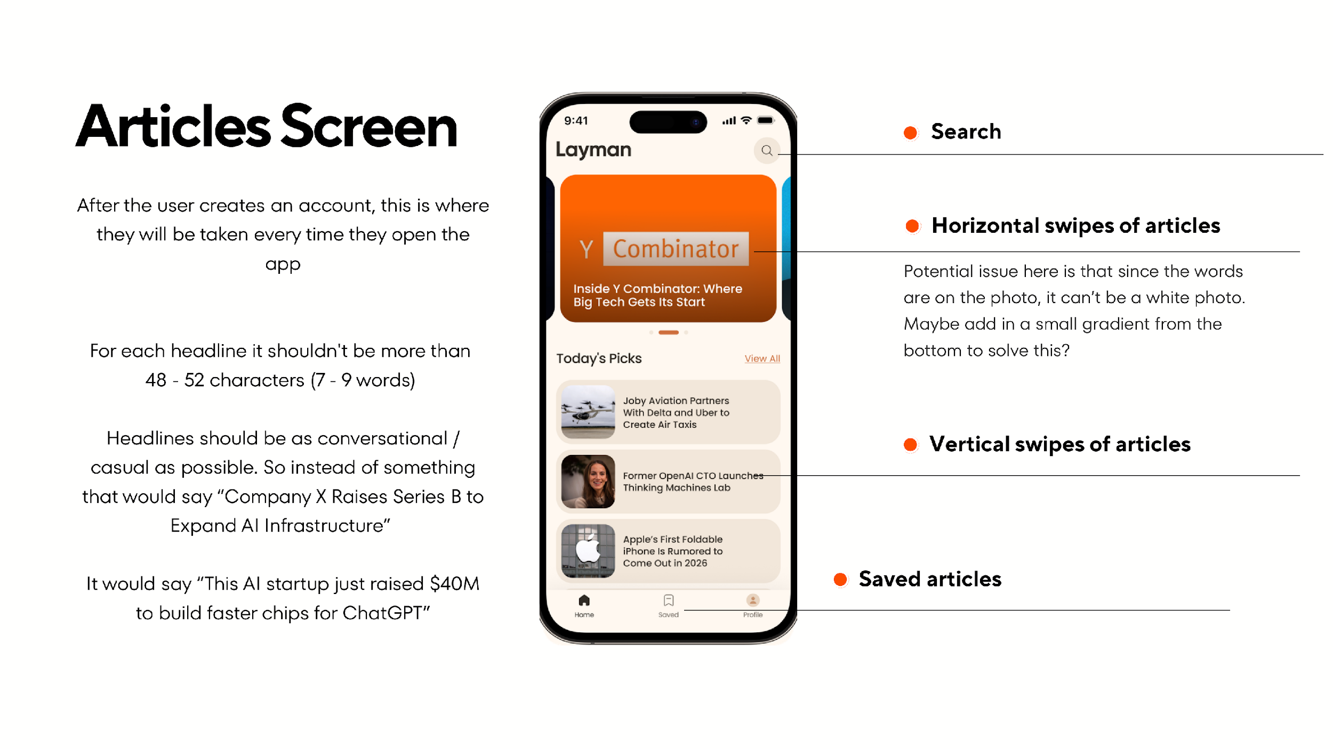
Header
- "Layman" logo text with a search icon (top right)
Featured Articles Carousel
- Horizontal swipeable cards with full-bleed article image
- Headline overlaid on the image — use a bottom gradient so text is always readable on any image
- Page indicator dots below the carousel
"Today's Picks" Section
- Section header with "View All" link
- Vertical scrollable list of article rows: rounded thumbnail on the left, headline text on the right
Bottom Tab Bar
- Three tabs: Home | Saved | Profile
Headline Rules
- Maximum 48–52 characters (7–9 words)
- Conversational and casual tone (not formal news-speak)
- Example: Instead of "Company X Raises Series B to Expand AI Infrastructure", write "This AI startup just raised $40M to build faster chips for ChatGPT"

4. Content Screen (Article Detail)
When the user taps an article, this is where they read the content.
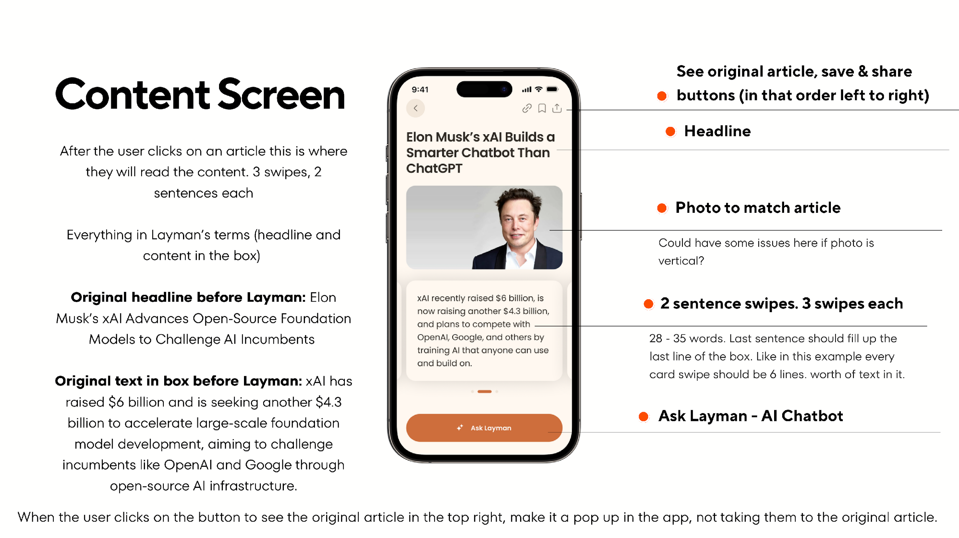
Top Bar Icons (left to right)
- Back button (left side)
- Link icon (view original article), Bookmark icon (save), Share icon (right side)
Headline
- IMPORTANT: Bold text, exactly 2 lines — match the font size from the mockup
Article Photo
- Below the headline, full width
Content Cards — 3 Swipeable Parts
- Each card contains 2 sentences summarizing a portion of the article
- IMPORTANT: Each card should be 28–35 words, filling exactly 6 lines of text — match the font size from the mockup
- Content must be written in layman's terms — simple, casual, easy to understand
- Page indicator dots to show which card the user is on (1 of 3)
"Ask Layman" Button
- Fixed at the bottom of the screen — opens the AI chatbot
Original Article Link
- When the user taps the link icon, show the original article in an in-app popup/modal (e.g., SFSafariViewController or WebView)
- Important: Do NOT navigate away from the app

5. Ask Layman (AI Chat)
A simple chatbot contextual to the article the user is reading.
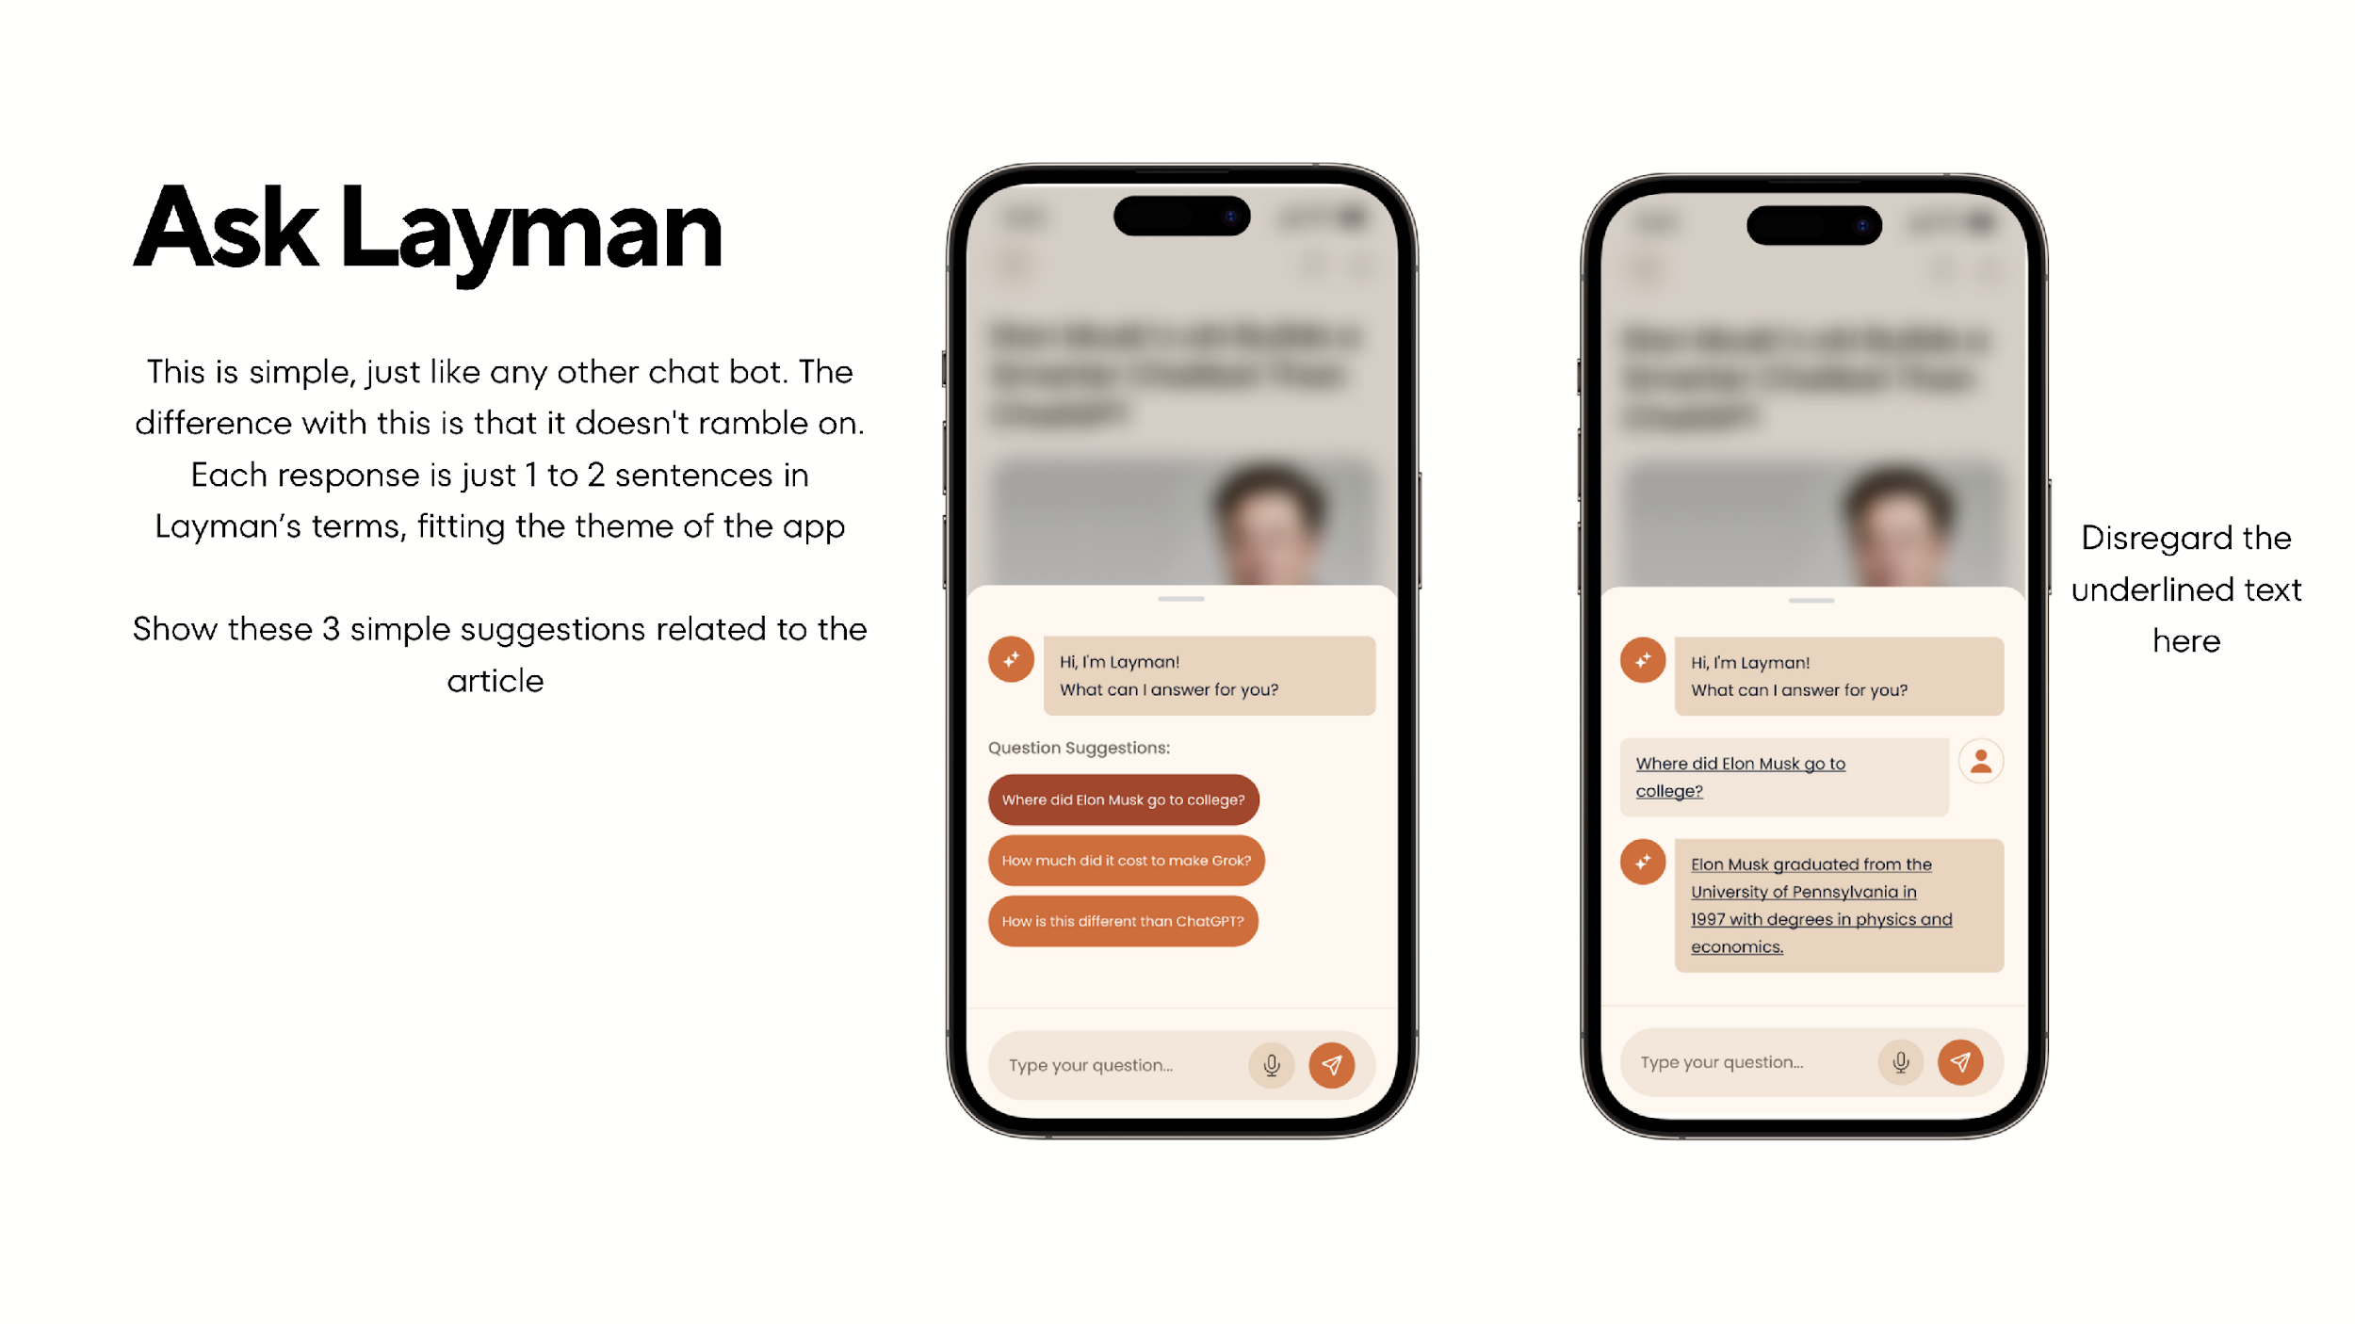
- Initial Message: "Hi, I'm Layman! What can I answer for you?" (with the Layman bot icon)
- 3 Question Suggestions: Auto-generated tappable chips/buttons related to the current article (e.g., "Where did Elon Musk go to college?", "How much did it cost to make Grok?")
- Text Input Bar: Placeholder "Type your question...", microphone button, send button
- AI Responses: 1–2 sentences max, in layman's terms — fitting the app's theme of simplicity
- Must use a real AI API: Integrate a free-tier AI service (Google Gemini, OpenAI free tier, Groq, etc.) — mocked responses are not acceptable
- Context-aware: The chatbot should receive the article context so its answers are relevant to what the user is reading

6. Saved Screen
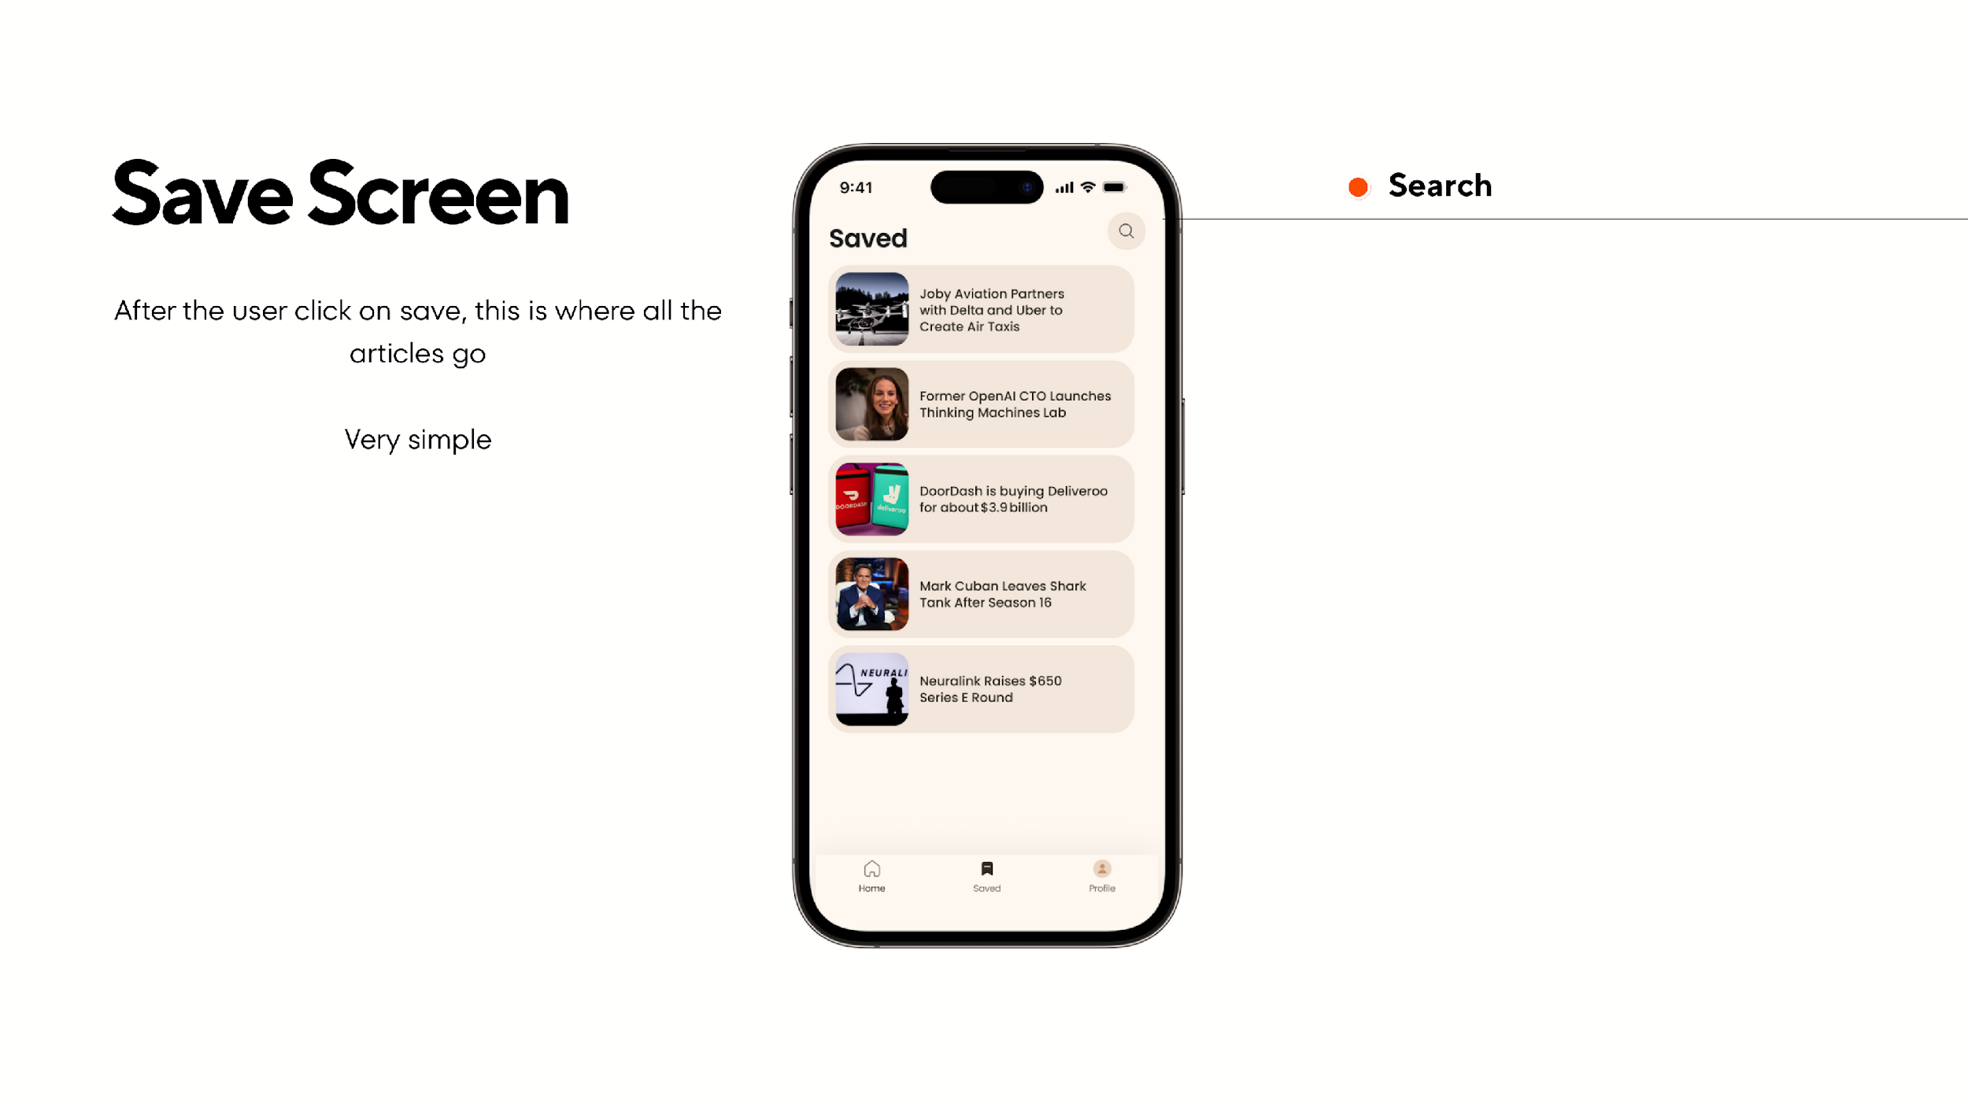
- Header: "Saved" with search icon (top right)
- Article List: Vertical list of saved articles — rounded thumbnail on left, headline on right (same style as "Today's Picks")
- Bottom Tab Bar: Same as Home screen

7. Profile Screen
- User info (name, email)
- Sign out button
- Any additional settings you see fit

Data

News API
Use any free news API to fetch real articles about business, tech, and startups:
- NewsData.io (https://newsdata.io) — free tier

Backend: Supabase
Use Supabase (free tier) for authentication and data storage.
Setup required:
- Create a free Supabase project at supabase.com
- Set up email/password authentication
- Create a saved_articles table (see schema below)
- Set up Row Level Security (RLS) so users can only read/write their own saved articles

Requirements
The assignment is evaluated in three parts:

Part 1: Authentication (15%)
- Supabase email/password sign-up and login
- Proper session management (persist login state)
- Clean sign-up/login UI matching the app's warm color palette
- Basic validation and error handling
- Supabase credentials stored securely (not hardcoded in plain text)

Part 2: UI & Screens (45%)
- Design fidelity: Exact match to the mockup — color palette (warm peach/orange gradients, cream/beige cards), typography, spacing, rounded corners, and layout
- Welcome screen with gradient background and swipe-to-start
- Featured articles horizontal carousel with image + headline overlay (with gradient for readability)
- "Today's Picks" vertical article list
- Critical: Article detail with 3 swipeable content cards — title exactly 2 lines, description exactly 6 lines per card
- Save/bookmark functionality (synced to Supabase)
- Search across articles (Home screen and Saved screen)
- Tab bar navigation: Home, Saved, Profile
- Smooth animations and transitions (carousel swipes, card transitions, screen navigation)
- Feels polished — not a prototype

Part 3: Chat Module — Ask Layman (40%)
- Functional AI chatbot using a real free-tier AI API (not mocked)
- Context-aware: the chatbot receives article context and answers questions about it
- 3 auto-generated question suggestions related to the current article
- Responses limited to 1–2 sentences, written in simple everyday language
- Chat UI matching the mockup: bot messages with icon, user messages on the right, suggestion chips in accent orange
- Text input with microphone and send buttons (microphone can be a non-functional placeholder)
- Smooth message animations

AI Workflow Requirement
You must demonstrate AI-assisted development using an AI coding tool as your primary development environment.
Accepted tools (use whichever you have access to):
- Claude Code
- Cursor
- Windsurf
- Antigravity
- GitHub Copilot
- Cline (VS Code extension)
- Or any other AI coding assistant — just mention which tool you used in your README
Required:
- Use your chosen AI coding tool as your main development environment
- Screen recording showing your AI-assisted workflow (prompting, iterating, debugging)
- Best practice: Use CLI commands and built-in skills/slash commands (e.g., /commit, /review, project context files) to streamline your workflow — this is the modern best practice over manual setups
- CLAUDE.md, .cursorrules, or equivalent AI context file to guide the AI
- Demonstrate effective prompting and iteration with AI

Evaluation Rubric
Criteria | Weight | What We're Looking For
AI Workflow | 40% | Effective prompting, good use of CLI skills/slash commands, iteration flow, knowing when to guide vs. let AI lead, handling AI mistakes gracefully
UI Polish & Fidelity | 35% | Exact match to mockup design, animations, visual attention to detail, feels like a real app
Code Quality | 25% | Clean architecture (MVVM), error handling, secure credential management, readable code

Deliverables

1. GitHub Repository
- Complete source code
- README.md with setup instructions, Supabase config (env variables), News API key config, AI API key config, and screenshots
- CLAUDE.md, .cursorrules, or equivalent AI context file you used during development

2. Screen Recording (15–30 min)
Record your development session showing:
- How you prompt and iterate with your AI coding tool
- Using CLI commands, slash commands, and skills to speed up development
- Building features with AI assistance
- Debugging or problem-solving with AI
- Your thought process when the AI gets stuck or makes mistakes
Tips: Use Loom or similar. Speed up repetitive parts. Narrate your thought process.

3. App Demo Video (Required)
A short video (2–5 min) demonstrating the running app:
- Walk through all screens: Welcome > Auth > Home > Article Detail > Chat > Saved > Profile
- Show the swipeable content cards and article carousel
- Demonstrate the AI chatbot with a real question
- Show saving/unsaving an article

4. TestFlight Build (Bonus)
Submit a TestFlight build so we can test the app on a real device. This is not required but earns bonus points.

Bonus Points
Advanced AI Workflows (stand out from other candidates):
- Using CLI skills and slash commands effectively (e.g., /commit, /review, /test, database CLI tools)
- Leveraging AI context files (CLAUDE.md, .cursorrules) to guide the AI with project-specific knowledge
- Subagents or multi-agent task breakdown for parallel development
- Automated test generation via AI
- Using Supabase CLI (supabase init, supabase db push) for database setup instead of manual dashboard work
Bonus App Features:
- TestFlight build
- Real-time sync of saved articles using Supabase Realtime
- Push notifications (e.g., "OpenAI raises $10B — read about why")
- Dark mode support with proper color adaptations
- Haptic feedback on interactions
- Reading streaks (daily streak counter to encourage engagement)
- Functional voice input in the chatbot (not just a placeholder)
- Offline reading support for saved articles

Submission
Use the submission link provided in the email to submit your assignment.
Deadline: 5 days from receiving this assignment
Questions? Reach out to team@thebrewapps.com

Resources
- Supabase Documentation — https://supabase.com/docs
- Supabase CLI — https://supabase.com/docs/guides/cli (for bonus points)
- NewsData.io — https://newsdata.io
- Google Gemini Free API — https://ai.google.dev
- Groq Free API — https://console.groq.com
- OpenAI API — https://platform.openai.com

Good luck!

